Risk Based Decision Making of Mobile Mooring System
Mohd. Faris Khamidi
Senior Lecturer in Department of Civil Engineering,
Faculty of Engineering
Universiti Teknologi PETRONAS, Perak, Malaysia
mfkhamidi.petronas.com.my

Silvianita
PhD Student, Department of Civil Engineering,
Faculty of Engineering
Universiti Teknologi PETRONAS, Perak, Malaysia
Department of Ocean Engineering
Institut Teknologi Sepuluh Nopember, Surabaya, Indonesia

V.J. Kurian
Professor in Department of Civil Engineering,
Faculty of Engineering
Universiti Teknologi PETRONAS, Perak, Malaysia

Abstract—Floating structure uses mooring system for station keeping in any water depth. The mooring accident can cause serious injury or damage to the vessel, and hence it is necessary to establish systematic decision making for minimizing the risk failure. This paper investigates the risk based decision making that involve potential causes and possible outcomes of mooring accidents. The potential causes of mooring failure are analyzed using Fault Tree Analysis (FTA) and the possible sequence outcomes of the accident events are defined using Event Tree Analysis (ETA). FTA is a deductive method that is useful to generate the potential causes of mooring system failure into undesired events. ETA is an inductive method which is helpful to define all possible outcomes of accidental event. The objectives of this paper are to determine the potential causes of mooring system failure, to find the possible sequence outcomes of an accidental (initiating) event and to evaluate the frequency of hazards. The initiating events for mobile mooring system that are investigated are mooring line break (MLB), anchor failure (AF), anchor handling failure (AHF) and appurtenances connection failure (ACF). These events are then broken-down in order to determine the root cause, to define the sequence of the outcomes and to evaluate the frequency of occurrence based on the engineering judgments. The result of the study will be helpful to predict the risk level and to define the mitigation strategy of mobile mooring system.

Keywords-decision; events; failure; making

1. Introduction
Floating structure uses mooring systems for station keeping. The frequency of failure related to mooring system since 1981 to 2009 is 0.1333 per unit year [1]. The platform used for this case study is a semi submersible column stabilized pipe lay barge fitted with 12 point mooring system to aid controlled movement during pipe lay operations. The vessel has a hull with four columns and two pontoons. The main problems related with mooring system failure are caused by anchor failure, mooring lines, mooring devices and winching equipment. This paper investigates the potential causes and their consequence of mooring system failures. The objectives of this paper are: (1) to determine the potential causes of mooring system failure; using FTA (2) to define the possible sequence outcomes of an accidental (initiating) event using ETA; (3) to evaluate their frequency of hazard. Bow ties are composed of a fault tree to determine the potential causes and event tee to define the possible consequences at main critical event. The frequency of occurrences are estimated through expert judgments since there is insufficient data to determine the events [2]. The experts evaluate the frequency of occurrence using IMO standards as shown in Table 1and the consequence class based on ISO standards as shown in Table 3. The result of bow ties will be described in the risk matrix graphs with frequency on the y axis and consequence class on the x axis. There are four events as critical events in mooring system failure which consist of mooring line breakage (MLB), anchor failure (AF), anchor handling failure (AHF) and appurtenance connections failure (ACF) [3-4]. This paper develops the bow tie analysis for appurtenance connection failure as can be seen in Fig. 1. The FTA was developed using DPL Syncopation software [5].
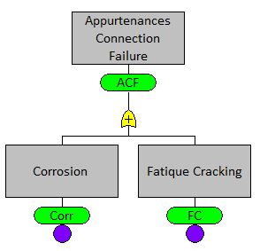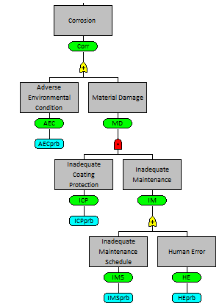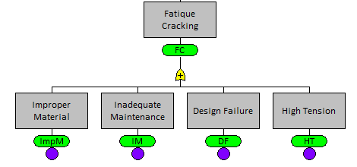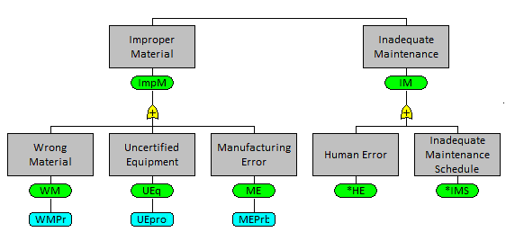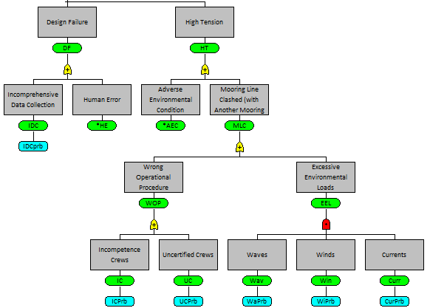

Fig. 1. Appurtenances Connections Failure (ACF)
2. Fault Tree Analysis (FTA)
FTA is a deductive approach that consists of symbols and gate in order to describe the process of system failure. This paper develops FTA for four major types of failure of mooring system which are MLB, AF, AHF and ACF. In order to analyze the fault tree, the evaluation uses the rules of Boolean Algebra [6]. First step to evaluate the fault tree is to determine the cut set and minimal cut set. Cut set (CS) is a group of failure events that if they all occur, cause the top event to occur. Minimal cut set (MCS) is a minimal group of failure events that can still cause the top event to occur [7].
Table 1. Frequency Index [8]
FI | Frequency | Definition | F (per ship year)
7 | Frequent | Likely to occur once per month on one ship | 10
5 | Reasonably probable | Likely to occur once per year in a fleet of ships, i.e. likely to occur several times during a ships life | 10⁻¹
3 | Remote | Likely to occur once per year in a fleet of 1000 of ships, i.e. 10% chance of occurring in the life of 4 similar ships | 10⁻³
1 | Extremely remote | Likely to occur once in 100 years in a fleet of 1000 ships, i.e.1% chance of occurring in the life of 40 similar ships | 10⁻⁵

In order to quantify the frequency of failure, the basic event in a system failure needs to be found. Since it is very difficult to collect the past record data for FTA, it is necessary to collect the expert judgments. The experts evaluate all the basic causes in the fault tree diagram and give their judgments based on their experience using Table 1 as the guidance. Table 2 is the minimal cut set of ACF based on the DPL software output. The result shows that the frequency of occurrence of ACF is 0.0438 per unit year which is classified as occasional.
Table 2. Cut Set of ACF
Rank | Cut Set | Code | Order | Importance Level
1 | Excessive Waves, Winds, Current | EWa, EWi, ECu | 3rd | 0.037
2 | Adverse Environmental Condition | AEC | 1st | 0.003
3 | Human Error | HE | 1st | 0.0009
4 | Incomprehensive Data Collection | IDC | 1st | 0.0007
5 | Inadequate Maintenance Schedule | IMS | 1st | 0.0005
6 | Uncertified Crews | UC | 1st | 0.0004
7 | Uncertified Equipment | UE | 1st | 0.0004
8 | Incompetence Crews | IC | 1st | 0.0004
9 | Wrong Material | WM | 1st | 0.0003
10 | Manufacturing Error | ME | 1st | 0.0002
 | Probability of ACF |  |  | 0.0438

3. Event Tree Analysis (ETA)
ETA is an inductive method that defines all potential consequence resulting from an accidental (initiating) event, those potential consequences being called consequence spectrum [9]. Generally the pivotal event splits in an event tree are binary, success or fail, yes or no condition. A list of the outcomes can be determined and evaluated by multiplying the event frequency in the path events. Event tree as an graphical model of an accident scenario that illustrated the multiple outcomes and their frequency is based on the following definitions [10]:
      - IE (Initiating Event) are failure or undesired event which initiates the beginning of an accident sequence. The IE can result in an accident, depending on successful operation of the hazard corrective techniques of the system.
      - PE (Pivotal Event) is mediator event between the IE and the final accident.
      - Accident scenarios are list of events that eventually come up with an accident.
Event tree diagram of ACF is shown in Fig. 2. The diagram shows the sequence of ACF consequence completed with the frequency of occurrence based on the expert judgments. The frequency of ACF in the first path is derived from the result of FTA which is 0.0438 per unit year.
Appurtenances Connection Failure | Mooring Line Lost Its Connection From Anchor | Mooring Line Breaks Free / Clashed with Other Line | Pipe Lay Vessel Lost Its Position & Other Mooring Line Fails to Keep Pipe Lay Vessel to Its Position | AHTS Fail to Take Immediate Safety Action of The Mooring Line | Outcomes | Frequency
F = 0.0438 | F = 0.0003 | F = 0.0002 | F = 0.00007 | F = 0.00003
YES  F = 0.00003  YES  F = 0.00007  NO  F = 1 - 0.00003  = 0.9997  YES  F = 0.0002  NO  F = 1 - 0.00007  = 0.9993  YES  F = 0.0003  Failure  F = 0.0438  NO  F = 1 - 0.0002  = 0.9998  NO  F = 1 - 0.0003  = 0.9997 |  |  |  |  | Pipe Lay Vessel Drift from Its Design Path  Pipe Lay Vessel Recovery (Maneuver to its Position)  Pipe Lay Vessel Stay on Its Position: Project Delay  Safety Concern Needed  Appur-tenances Connec-tion is Safe | F =  5.5188.10⁻¹⁸  F =  1.8395.10⁻¹³  F =  2.6278.10⁻⁹  F =  1.31374.10⁻⁵  F =  4.3786.10⁻²
Fig. 2. ETA of Appurtenances Connections Failure

- Bow Tie
Bow tie analysis is composed of FTA and ETA with the same critical events. Bow ties are broken down into the potential causes on the left part and generate the sequence of possible consequence of the right part as shown in Fig. 3. The next step is to describe the result of bow tie analysis into risk matrix graphs. Each outcome of an event is placed in the risk matrix according to its frequency as shown in Table 1 and its class of consequence as can be seen in Table 3.
Table 3. Class of Consequences [11]
Consequences |  |  |  |  | Class
Severity Rating | People | Assets | Environment | Reputation | Ranking
0 | Zero Injury | Zero Damage | Zero Effect | Zero Impact | C1
1 | Slight Injury | Slight Damage | Slight Effect | Slight Impact | C2
2 | Minor Injury | Minor Damage | Minor Effect | Minor Impact | C3
3 | Major Injury | Major Damage | Major Effect | Major Impact | C4
4 | Single Fatality | Major Damage | Major Effect | Major National Impact | C5
5 | Multiple Fatalities | Extensive Damage | Massive Effect | Major International Impact | C6
Fig. 3. Bow Tie of ACF

Based on the event tree diagram as shown in Fig. 3, the outcomes of ACF are tabulated in Table 4 to identify the class of consequence. The class of consequence is estimated by the expert according to the definitions given in Table 3. The output of this step as shown in Table 4 is a list of ACF sequence associated with their frequency and their class of consequences.

Table 4. The ACF Frequency and Consequence Class of Consequences
No | Outcomes | Frequency | Class of Consequences
1. | Pipe Lay Vessel Drift from Its Design Path: Damage on Pipeline Objects, Project Delay, Partial Construction Damage on Pipe Lay Vessel | 5.5188.10⁻¹⁸ | C6
2. | Pipe Lay Vessel Back to Design Path: Project Delay, High Priority Safety Concern Needed | 1.83954.10⁻¹³ | C5
3. | Pipe Lay Vessel Stay on Its Position: Project Delay, High Safety Concern Needed | 2.62782.10⁻⁹ | C4
4. | Safety Concern Needed | 1.31374.10⁻⁵ | C3
5. | Appurtenances Connection is Safe | 4.378686.10⁻² | C2

Risk matrix is developed based on the frequency of occurrences and class of consequence categorization. Therefore the risk matrix with the decision classes revealed is as the following very high, high, medium and low as shown in Table 5.

Table 5. Risk Level
Severity  Frequency | Negligible | Slight | Minor | Major | Critical | Catastrophic
Frequent | High | Very High | Very High | Very High | Very High | Very High
Probable | Medium | High | High | Very High | Very High | Very High
Reasonably Probable | Medium | High | High | Very High | Very High | Very High
Occasional | Medium | Medium | Medium | High | High | Very High
Remote | Low | Medium | Medium | Medium | Medium | High
Improbable | Low | Low | Low | Medium | Medium | Medium
Extremely Remote | Low | Low | Low | Low | Low | Medium

The risk matrix graphs consist of x axis corresponding to the six consequence classes and y axis corresponding to the frequency of occurrences. There are four zones defined in the risk matrix corresponding to the risk level. From the results presented in the event tree (Fig. 2) and in Table
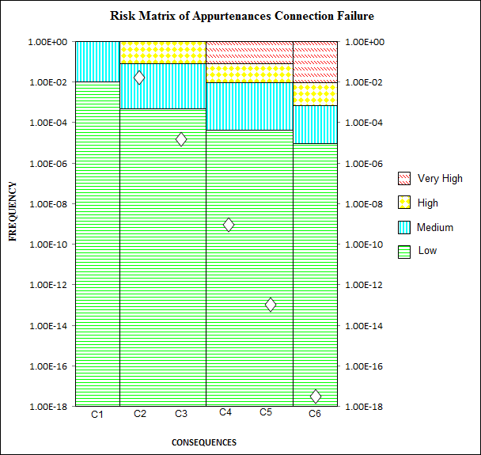

Fig. 4. Risk Matrix of ACF
Risk matrix of ACF is shown in Fig 4. The appurtenances connection is located in medium level of risk with the frequency of occurrence 4.378686.10⁻². The extreme condition which is the pipe lay vessel will drift from its design path is in the lowest level of risk and considered as extremely remote.

5. Conclusion
Bow tie analysis consists of FTA and ETA which are useful to define all the potential causes and possible consequence of an event respectively. Mooring system failure was investigated using bow tie analysis that divides the system into four parts which are MLB, AF, ACF, and AHF. The key points from this paper can be highlighted as follows:
- The main causes of ACF are corrosion and fatigue cracking, FTA shows the frequency for possible failure of ACF is 4.38.10⁻² per year which is classified as occasional.
- The sequence path of ACF was developed using ETA. The result shows that the frequency of extreme condition pipe lay vessel drift from its design path is 5.5188.10⁻¹⁸ which is classified as extremely remote.
- The bow tie results are described in the risk matrix with frequency on the y axis and consequence on the x axis. The graph shows that the appurtenances connections are in the medium level of risk.

References
[1] H. S. E. (HSE), "Accident Statistics for Offshore Units on the UKCS 1990-2007," The United Kingdom Offshore Oil and Gas Industry Association Limited, London2009.
[2] T. Deacon, et al., "Human Error Risk Analysis in Offshore Emergencies," Journal of Safety Science, 2010.
[3] Silvianita, M.F. Khamidi V.J. Kurian "An Application of Fault Tree Analysis for Mobile Mooring System," in International Conference on Civil, Offshore & Environmental Engineering, Kuala Lumpur, Malaysia, 2012.
[4] Silvianita, M.F. Khamidi, V.J.Kurian "Development of a Framework for Safety Assessment of Mobile Mooring System," presented at the 8th Asia Pacific Structural Engineering and Construction Conference 2012 (APSEC 2012) & 1st International Conference on Civil Engineering Research (ICCER 2012), Surabaya, Indonesia, 2012.
[5] T. M. Chris Dalton, "Syncopation Software," ed, 2005.
[6] W. V. Michael Stamatelatos, Fault Tree Handbook with Aerospace Applications, 2002.
[7] C. A. Ericson. (2000). Fault Tree Analysis. Available: www.fault-tree.net
[8] I. M. O. (IMO), "Interim Guidelines for the Application of Formal Safety Assessment (FSA) to the IMO Rule Making Process," London, 1997.
[9] M. Rausand, "System Analysis Event Tree Analysis," in System Reliability Theory, Second Edition ed: Wiley, 2005.
[10] C. A. Ericson, "Event Tree Analysis," in Hazard Analysis Techniques for System Safety, ed: John Wiley & Sons, Inc, 2005.
[11] D. N. Veritas, "Marine Risk Assessment," Offshore Technology Report 2001/063, 2002.

