POTENTIAL USE OF BASALTIC SOIL FOR DRILLING FLUID
Ahmad Bakri Zubir & Askury Abd Kadir
Geoscience & Petroleum Engineering Department,
Universiti Teknologi PETRONAS,
Bandar Seri Iskandar, 31750 TRONOH, Perak
askury_akadir@petronas.com.my

Abstract - Drilling fluid or drilling mud is a critical component in the drilling process, where it provides the gel to efficiently lift cuttings, maintain stable wellbore and produce sufficient hydrostatic pressure that could prevent the influx of formation fluids into the wellbore. For over eight decades, drilling grade barite remains to be the most profound weight material used to adjust drilling mud densities around the world. However, barite resources globally are depleting especially in terms of its quality, economical viability and attainability – thus making it more expensive. Understanding problems during drilling operations including loss of circulation material (LCM) and differential sticking could reveal more beneficial application of utilizing basaltic soil in this field as other existing remedy substances are expensive. Basaltic clay soil is seen as a potential alternative to be utilized in drilling fluids additive and also as barite substitute for the weighting agent. Based on literature reviews the significance of using basaltic soil is that is has the gel characteristics to lift up drilled cuttings, produces suitable mud weight and economically inexpensive for its abundance. Understanding the mineral constituent and alterations in weathered basaltic rock is also important in order to select the depth zone of basaltic soil with the desired compositions. Development of prototype drilling fluids using basaltic soil shall be tested using standard variations of mud tests on its rheological properties to determine basaltic soil’s most suitable application to be used in drilling operations. Based on the laboratory tests, the basaltic soil collected from Kuantan region exhibits the primary properties of lost circulation materials. However comparing to calcium carbonates, the low specific gravity of basaltic soil does not significantly affect mud weight if added into the mud to control loss circulation and differential sticking. True to the fact that basaltic soil and rocks are in abundance and can be cheaply produced, basaltic soil could be a potential loss circulation material additive in drilling fluids especially in drilling deepwater and ultra deep wells.

Keywords: Kuantan basalt, lost circulation material, basaltic soil, drilling fluid
INTRODUCTION
The objective of drilling operation is to drill, evaluate and complete a well that will produce oil or gas efficiently. Drilling fluids perform numerous functions that help make this possible. The primary functions of drilling fluids are to remove cuttings from the well, control formation and well pressure, suspend and release cuttings and maintain wellbore stability. A good drilling fluid can also enhance penetration rates, reduce wellbore problems and minimize formation damage (Ford, 2003). One of the most important properties of drilling fluids is that it should be able to provide sufficient hydrostatic pressure higher than the formation pressure.
Rapid depletion of barite mineral is occurring worldwide and the oil and gas industry in expected to see fall in barite supplies in the near future, thus results in increase in its price (Issham et al., 1999). The increase in worldwide drilling activities causes rapid increase in barite demand but shortage supplies of quality barite (Bruton, 2006).
Basaltic soil is currently being studied in order to determine its underlying potential to be utilized in drilling fluids and as weighting agent. The source of basaltic soil collected from Kuantan (Figure 1). In this research, parameters of the mud using basaltic soil as the main fluid additive component will be tested in terms of its rheological behavior, fluid loss, weight, density and solids content.
PROBLEM STATEMENT
Basaltic rocks undergo weathering processes from the exposure to agents of air, water and organic fluids. However, basalt weathers relatively fast compared to other rocks found on earth surface. There is mechanical and chemical weathering involved that eventually changes solid hard rock into smaller pieces and clay particles to form soils. The element of Fe and Al has shown almost complete immobility during the weathering process. Interestingly, Eggleton et al. (1987) postulated the significant increases in barite (BaSO₄) as weathering increases in basalt.
In addition, basaltic rocks which are rich in pyroxene and amphiboles are readily weatherable forming montmorillonite. This formation of montmorillonite is due to presence of high base saturation of alkaline earth cations, alkaline reaction and basaltic parent material. In this process iron, magnesium and silicon are released to combine with calcium and feldspars to from montmorillonite (Gurcharan and Murti, 1974).
Therefore, with the intactness of Fe elements, increase in barite and formation of montmorillonite, basaltic soil is seen to have some potential to be used in as beneficial additives in drilling fluids as well as a possible barite substitute for viscosifier and weighting agent.
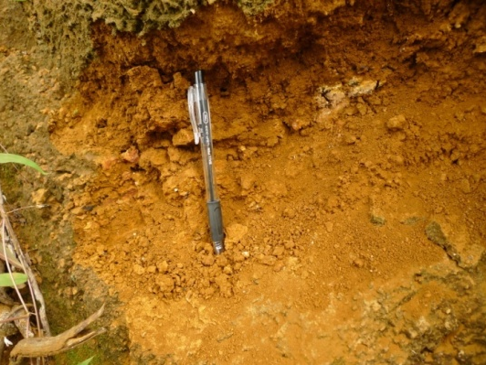
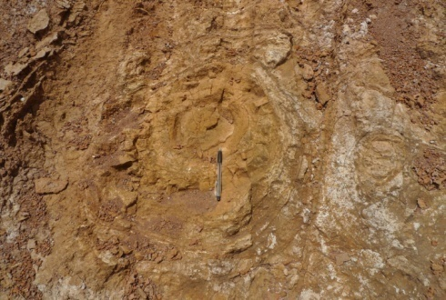

Fig. 1: Basalt soil undergone mechanical and chemical weathering

DRILLING FLUIDS
Modern drilling mud systems are designed to enable oil extraction from different geological formations by ensuring that oil well stability is maintained whilst enabling the extraction of oil from the production zone. In designing additive and ingredients of drilling fluids, accurate and consistent particle sizing is an important aspect. The American Petroleum Institute (API) has set up industrial standards of mud particles to be used in offshore and onshore drilling wells. Ideally, the mud particle size should be small enough to bridge across the pores within the formation being drilled, thus forming a “filter cake” which prevents the drill solids and other mud. As such, general particle sizes of mud should be not more than 100 microns for optimum mud building.
- Barite is commonly used as a weighting agent within both aqueous and non-aqueous drilling mud systems. Control of the particle size is important as the presence of coarse particles may lead to settling out, causing equipment damage, whereas fines may yield inadequate weighting and problems with formation damage.
- Calcium carbonate can be used in drilling mud not only as a weighting agent but also as a bridging material. It is often used in preference to barite because it is acid-soluble and can therefore be easily dissolved as part of the process of cleaning up the production zone.
- Bentonite or montmorillonite is used as a viscosifier in mud. Bentonite clay can swell up to four times of its original size when dispersed in water. This gelling effect made mud added with bentonite yields very high cutting carrying capacity. Bentonite dispersion in water has a mean size range between 3-50 microns to maximize surface contact with the surrounding.

FIELD OBSERVATION AND LABORATORY TEST
The basaltic soil profile in Kuantan is prominently characterized by its yellowish brown and reddish brown color, as weathering product of greenish black parent rock. Consistency of the soil is friable but becomes firmer as it depth increases. The morphological descriptions of the sample are presented in the Table 1.
Table 1: Physical observation of the specimen.
Sample | Location | Texture | Matrix Color | Consistency | Weathering Grade
1 | N 03° 53.402’  E 103°21.986’ | Clay | 10YR 4/2 | Friable | Highly Weathered
2 | N 03° 53.402’  E 103°21.986’ | Clay | 5Y2 4/4 | Firm | Highly Weathered
3 (Fresh Rock) | N 03° 53.312’  E 103°21.972’ | Fine microcrystalline, Porous, | 4N4 | Hard | Fresh
4 | N 03° 53.402’  E 103°21.986’ | Clay | 10YR 2/2 | Friable | Extremely weathered
5 | N 03° 53.788’  E 103°21.314’ | Clay | 5YR 3/4 | Friable | Extremely weathered
6 | N 03° 53.596’  E 103°21.286’ | Clay | 5YR .3/4 | Friable | Extremely weathered
7 | N 03° 56.914’  E 103°20.098’ | Clay | 10YR 4/2 | Hard | Moderately weathered
8 | N 03° 55.649’  E 103°21.147’ | Clay | 5YR 3/2 | Firm | Highly weathered
9 | N 03° 55.413’  E 103°21.0701’ | Silty Clay | 10R 3/4 | Friable | Highly weathered
The samples are highly weathered, with only one sample is moderately weathered as proposed by Turul & Gorpina (1997) on the weathering classification of basalt. It is predicted that these samples are ranges from 2.3 to 2.5g/cm³ in dry density. However, the density obtained from the basaltic soil ranging from 1.18 to 1.61 g/cm³ which are much more less than predicted. A similar study by Tan (1996) on samples from the same site also reveals almost the same density ranges from 1.22 to 1.60g/cm³. A possible explanation of this occurrence might be the extreme dissolution of mobile heavier elements such as Ca and Mn. A study of weathering behavior and physico-chemical characteristics of the basaltic rock and soil in Kuantan by Tan (1996) and Hamdan, et al. (2003) found that cations Na⁺, Ca²⁺, Mg²⁺ & K⁺ are generally low in concentrations, with K⁺, Ca²⁺ & Mg²⁺ all having values below than 5 ppm.
From the literature review, it is clear that using particle size that is too small leads to solids invasion and low permeability recovery as these particles will fill in the pores of the formation. Using particle sizes that are too large however result in low return permeability due to the filter cake formed them. Sieve meshes are configured in the following order: 600μ > 425μ > 325μ > 212μ > 150μ > 63μ > Pan. For this project, samples with the size range smaller than 63 microns are selected to be the main additive in building the basaltic mud. Fine particle size ensures that mixing of the mud ingredients produce a homogenous mud.
- Basaltic mud weight
In mud building, the 22.5 gm of agitated bentonite swells and gives the mud weight of 8.5-8.6 ppg (pound per gallon) with the yield point (YP) of 22-25. In this experiment, two samples (#8 & 9) were utilised to substitute bentonite. One hour after mixing the mud using the multimixer, contrary to expectation, both samples of basaltic soil did not swell. Thus, there is no viscosity produced by adding the current samples in building the mud. A possible explanation for this case may be that the basaltic soil should be grinded finer to a size between 20-30 microns in order to activate the gelling effect as experienced by bentonite additive.
The mud weight test also revealed undesired result – both samples only generate a maximum mud weight of 8.7 ppg – a weight that can be achieved by using ordinary bentonite additive. This leads to the current initial findings which proved that the current sample is not suitable to be used as a barite substitute. Current barite additive (SG 4.2) can attain a maximum mud weight of 19 ppg.

After determining the mud weight, samples were then placed in a 500ml beaker and left intact for 15 minutes for any other observations. It was a surprise to not only see that the soil sample does not swell and mix well with water but also approximately 50% of the particles settled down after the 15 minutes period. Next, the beaker was covered with aluminium foil to prevent any external contamination and left intact for 16-hours (Figure 2). The result was as expected where sample soil has not swelled over time and 95% have settled onto the bottom of beaker and the result tabulated in Table 2.
Table 2: Basaltic mud properties
Properties | Mud 1 (Sample 8) | Mud 2 (Sample 9)
Clay Swelling | No | No
Viscosity | Very Low | Very Low
Weight (ppg) | 8.7 | 8.6
Rapid settling of mud particles | Yes | Yes

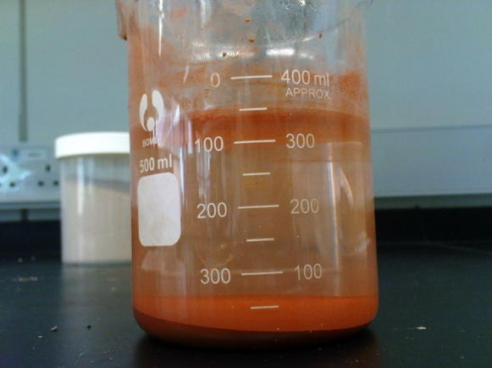
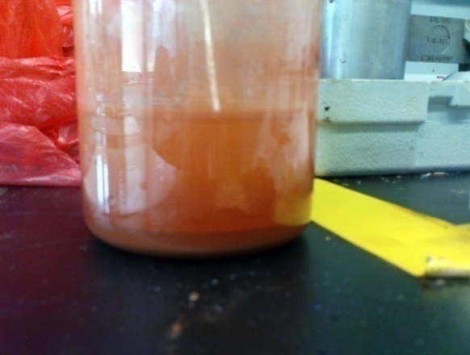

Figure 2: The behavior of basaltic mud after 15 minutes and 16 hours.

Interestingly though this characteristics is similar to that of fine calcium carbonate that been used as a weighting and bridging agent additive used in mud. About 22.5 gm of calcium carbonate is mixed with 350ml of water has shown the similar results to that of the basaltic soil sample. Calcium carbonate does not swell and mix well with water and settles down on the bottom of beaker when left intact over the same period of time.

Results and findings from this initial experiments show that basaltic soil may not be a suitable substitute for the current weighting and viscosifying agent in drilling fluids.
- Loss circulation material
Losses of whole mud to subsurface formations during drilling operations is called lost circulation or lost returns. In has been historically recorded that lost circulation has been one of the primary contributors to high mud costs. Other drilling problems are wellbore instability, stuck pipe and even blowouts have been the result of lost circulation (Swaco, 1998). In common, lost circulation occurs in two ways:
1. Naturally occurring losses - Invasion or mud loss to formations that is porous, permeable, cavernous, vugular, fractured or unconsolidated.
2. Mechanically induced losses - Fracturing which is mud loss due to hydraulic fracturing from excessive induced pressures. This includes high hydrostatic pressure due to high mud weight, and high pressure resulting from excessive ECD (Equivalent Circulation Density).
Lost circulation and differential sticking costs the industry hundreds of millions of dollars each year in lost or delayed production and in spending to deal with drilling problems, repair faulty primary cement jobs and replace wells irreparably damaged by lost circulation (Schlumberger, 2004). Good planning and proper drilling practices can help in preventing lost circulation and differential sticking by minimizing excessive pressures on the formation.
Commercially available LCM products encompass a wide array of materials. Moreover, if it can be pumped down a well, it probably has been at one time or another. Particle shapes are granular, flake or fibrous at sizes denoted as fine, medium or coarse.
It seems adequate to describe that basaltic soil collected from Kuantan, Pahang is not suitable to be used as barite substitute as it does not have sufficient density to be effectively in weighting drilling fluids. However, after completing the tests above, basaltic soil shows a similar result to that of lost circulation materials. The primary indicator of LCM is the insolubility of soil in water.
As for basaltic soil collected from Kuantan region, it exhibits the primary properties of lost circulation materials. However comparing to calcium carbonates, the low specific gravity of basaltic soil does not significantly affect mud weight if added into the mud to control loss circulation and differential sticking. True to the fact that basaltic soil and rocks are in abundance and can be cheaply produced, basaltic soil could be a potential loss circulation material additive in drilling fluids especially in drilling deepwater and ultra deep wells, as shown by Figure 3.

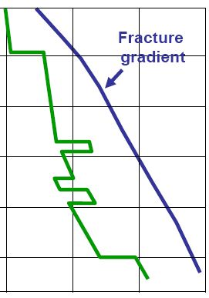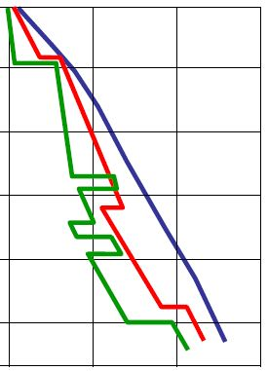
Pore Pressure
Fracture
Gradient
Depth
Formation Damage
Kick
Mud Density
Mud Density
Pore Pressure
Figure 3: Normal drilling (left) vs deepwater drilling (right).

There are many challenges in deepwater and ultra deep drilling operations. Even in shallow depth formation pore pressure and fracture gradient are very close to each other Figure 3), causing a crucial need to maintain specific mud weight for drilling (Rees, 2009). At extreme water depths (+3,500m), this low fracture gradient (due to the lack of overburden) and low equivalent pore pressure make drilling impractical (Swaco, 1998). The low fracture gradients also present lost circulation problems from surge and swab pressures, making surge, swab and ECD pressures significant concerns for all deepwater drilling operations.
The tests were performed to compare the differences of mud weight and other rheological properties between the commercial LCM and basaltic soils (Figure 4). The concentration of lost circulation material is increased incrementally at 20g, 40g and 60g to simulate the concentration of LCM at site during normal drilling and during period of differential sticking and loss circulation. The 20g, 40g and 60g respond to 20ppb (pound per barrel), 40ppb and 60ppb in field units.

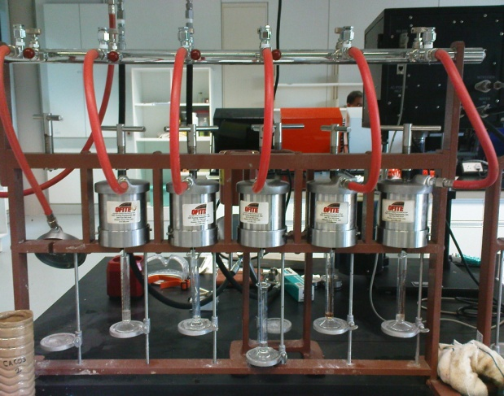
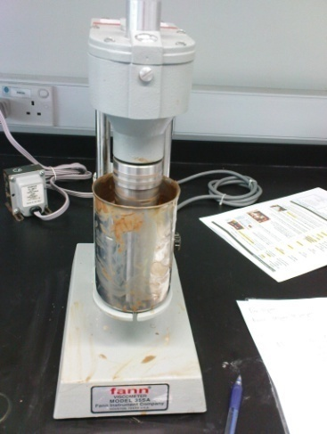
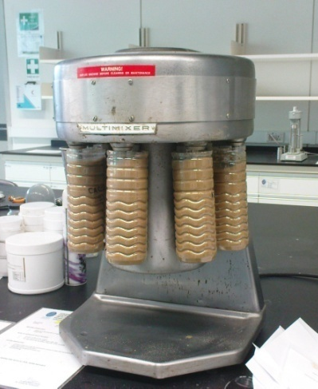

Figure 4: Mud building (left); rheological testing (centre); API filtrate testing (right)
This test is important as a step in determining the effectiveness of using basaltic soil and rock as LCM. The results are tabulated in Table 3. Abbreviation used in the test: MW = Mud Weight (ppg); PV = Plastic Viscosity (Higher PV values means higher solids content in mud); YP = Yield Point (Cutting carrying capacity of mud); API Fl = Filtrate loss (ml/30 minutes under 100psi pressure).
From the LCM comparison (Table 3), every LCM has its own advantages and disadvantages. Relating this to drilling deepwater wells that require the usage of low specific gravity LCM, nut plug, mica and basaltic soil seemed to be good candidates. However, when considering deepwater drilling factors such as surge/swab pressure, HSE issues and LCM integrity, basaltic soil seemed to be the best LCM to be used in deepwater wells. In addition to natural challenges such as sudden overburden zones and high pressure formation in deepwater drilling that is prone to lost of circulation and differential sticking, usage of current commercially available LCM’s poses different advantages and disadvantages. Basaltic soil however, has a good potential to be utilized in this field as it insoluble and low in specific gravity. It may be used as bridging agent and lost circulation materials in deepwater wells without neither significantly increasing original mud weight nor increasing surge and swab pressures. Furthermore basaltic soils abundances and economically inexpensive to produce makes it an even more competitive lost circulation material.

Table 3: LCM mud comparison test
Grams (g) | Bentonite mud (control) |  | Basaltic Soil |  | Calcium Carbonate | Mica | Nut Plug |  | Basaltic Rock
20 | MW: 8.7  PV: 3.5  YP: 15  API Fl: 6 |  | MW: 8.8 |  | MW: 8.9 | MW: 8.8 | MW: 8.8 |  | MW: 8.9
 |  |  | PV: 2 |  | PV: 6 | PV: 8 | PV: 5 |  | PV: 1
 |  |  | YP: 21 |  | YP: 22 | YP: 20 | YP: 20 |  | YP: 24
 |  |  | API Fl: 7 |  | API Fl: 5 | API Fl: 6 | API Fl: 3.5 | API Fl: 6.5
40 | MW: 8.7  PV: 3.5  YP: 15  API Fl: 6 |  | MW: 8.85 |  | MW: 9.2 | MW: 8.9 | MW: 8.9 |  | MW: 9.1
 |  |  | PV: 3 |  | PV: 4 | PV: 4 | PV: 9 |  | PV: 3
 |  |  | YP: 31 |  | YP: 28 | YP: 22 | YP: 15 |  | YP: 36
 |  |  | API Fl: 6 |  | API Fl: 4 | API Fl: 3 | API Fl: 2.5 |  | API Fl: 6
Other Observation | N/A |  | Mud becomes red in color and viscosity increases |  | High mud density | Mica flakes settles to bottom after a period of time. | Generation of a lot of bubbles |  | Highly viscous

In this part, the author has contacted Mr. Azhan from Scomi Oiltools, Malaysia’s leading drilling fluids solution to gain information on economically evaluating the potential of basaltic soil as LCM. Below is the latest pricelist and production cost contribution of common LCM obtained from Scomi Oiltools.
As compared to LCM in Table 5, the economic potential of basaltic soil is expected to be very high as basaltic soil can be locally produced, where the sources are abundant in Kuantan, Pahang and Segamat, Johor. In addition to that, the friable character of basaltic soil caused it to use less energy in drying and grinding into powdery LCM. It is expected that mass production of basaltic soil will much lower than 7 USD. From discussion with Mr. Azhan from Scomi Oiltools, it is deduced that the price of basaltic soil as LCM can be sold in 25kg sacks around 3.5-6 USD.

Table 5: LCM pricelist adopted from the Scomi Oiltools (M) Sdn Bhd.
LCM | Price  (USD / 25kg sacks) | Production Cost Contribution
Calcium Carbonate | 7 USD | Locally produced. Relatively higher cost of extracting carbonate rocks from carbonate hills. Consume high amount of energy to grind hard carbonate rocks into powdery LCM during production.
Mica (not used anymore due to HSE issues) | 8 USD | Imported product. Not used anymore in Malaysia due to HSE issue. Logistics cost on shipping
Nut Plug (coconut shell type) | 10 USD | Imported from India. Consume high amount of energy to dry & grind coconut shells during production phase. Logistics cost on shipping.
Deformable Graphite | >24 USD | Imported product. Uses complex technologies to extract and produce deformable graphite. Logistics cost on shipping.

CONCLUSION
The basaltic soil from Kuantan is not suitable to be used as a substitute for weighting and viscosifying agent. However, it can be used as lost circulation materials in deepwater well drilling. Economic evaluation of basaltic soil as LCM also implies that this material is cheaper than the price of existing LCM. Although basaltic soil is a good candidate as LCM in deepwater wells, many other detailed and more specific experiments must be done before it can be commercialized in the mainstream oil and gas industry.
REFERENCES

- Bruton, J.R., Bacho, J. & Newcaster J.A. (2006). ”The Future of Drilling Grade Barite Weight Material - A Case for a Substitute Specification” , SPE & M-I Swaco.
- Eggleton, R.A., Foudoulis, C. & Varkisser, D., (1987). “Weathering of Basalt: Changes in Rock Chemistry and Mineralogy”, Department of Geology, Australian National University of Canberra, Australia.
- Ford, J., (2003), “Chapter 9: Drilling Fluids”, Department of Petroleum Engineering, Heriot-Watt University, Heriot-Watt.
- Gurcharan, S., Krishna Murti, G.S.R., (1974). “Mineralogy of a few Basaltic Soils of Madhya Pradesh”, Division of Agricultural Physics, Indian Agricultural Research Institute, New Delhi.
- Hamdan, J., Peli, M. & Ruhana, P., (2003). “Weathering Behaviour of a Basaltic Regolith from Pahang, Malaysia”, Pertanika Journal of Tropical Agricultural Sciences, Universiti Putra Malaysia Press.
- Issham Ismail, Abdul Razak Ismail & Juhari Yang (1999), “Managing Drilling Mud Weight Using Ilmenite“, Faculty of Chemical and Natural resources engineering, Universiti Teknologi Malaysia (UTM), Johor Bahru.
- Rees, A. (2009). “Deepwater Drilling and Well Control”, Lillehammer Energy Claims Conference, Norway, 2009
- Tan, B. K., (1996). “Physico-chemical properties of basalt soil samples from Kuantan, Pahang”, Earth Sciences, Geology Department, Universiti Kebangsaan Malaysia, Retrieved August 2010, from http://pkukmweb.ukm.my/~jsm/english_journals/vol25num2_1996/vol25num2_96page115-123.html
- Turul A. & Gurpinar O., (1997). “A Proposed Weathering Classification for Basalts and Their Engineering Properties”, International Association of Engineering Geology
- Schlumberger, (2004). “A Safety Net for Controlling Lost Circulation”, Oilfield Review.
- Swaco, M. I., (1998). “Drilling Fluids Manual”, Houston, Texas.

