A spatial decision support system (SDSS) for sustainable tourism planning in Cameron Highlands, Malaysia
M Aminu¹, A N Matori¹and K W Yusof¹
Civil Engineering Department, UniversitiTeknologi PETRONAS Seri Iskandar, 31750 Tronoh,PerakDarulRidzuan, Malaysia.
Abstract.The study describes a methodological approach based on an integrated use of Geographic Information System(GIS)and Analytic Network Process (ANP) of Multi Criteria Evaluation (MCE) to determine nature conservation and tourism development priorities among the highland areas. A set of criteria and indicators were defined to evaluate the highlands biodiversity conservation and tourism development. Pair wise comparison technique was used in order to support solution of a decision problem by evaluating possible alternatives from different perspectives. After the weights have been derived from the pairwise comparison technique, the next step was to compute the unweightedsupermatrix, weighted supermatrix and the limit matrix. The limit matrix was normalized to obtain the priorities and the results transferred into GIS environment. Elements evaluated and ranked were represented by criterion maps. Map layers reflecting the opinion of different experts involved weresummed using the weighted overlay approach of GIS. Subsequently sustainable tourism development scenarios were generated.The generation of scenarios highlighted the critical issues of the decision problem because it allows one to gradually narrow down a problem.
Keywords: Conservation; Analytic Network Process; Geographic Information System; Sustainable development.

1. Introduction
Cameron highlands reflect an extraordinary diversity of Malaysia. It is a land of breath taking scenery with cool lush mountain peaks, nature trails, waterfalls, tea plantations, terraces of vegetable, fruit and flower gardens. Owing to a variety of habitats with fascinating landscape, the highland supports an incredibly high species biodiversity with a high level of endemism. Cameron highlands forests are important water catchment areas providing water supply not only to the local residents but also to the rest of Malaysians living further downstream of the catchment forests [1].
However, over the last two decades the beautiful scenery of Cameron Highlands is fast being replaced with forest being cleared with the drive to promote Malaysia as an important tourism destination [1]. The sensitive forest areas are being cleared for resort and condominium construction as well as land clearing for agricultural activities. The highland is characterized by uncontrolled development thereby causing habitat and water disruption [2]. Thus, appropriate protection and management of the highland is essential to enable these ecosystems to survive and continue to provide important goods and services.
Sustainable tourism can in fact be a major tool for the conservation of such areas and for raising the environmental awareness of residents and visitors.Such form of tourism conserves both natural and cultural assets; it guarantees the protection of nature and indigenous cultures. Sustainable tourism provides mechanisms to preserve threatened areas that could protect wildlife [3].Sustainable tourism planning is enhanced by applying a tool like Geographic Information System (GIS) and techniques of Multi Criteria Evaluation (MCE). Spatial data can be used to explore conflicts, examine impacts and assist decision-making. GIS is further strengthened by its capability of working along with Analytic Network Process (ANP) of MCE, which could further facilitate and offer more tools to sustainable tourism planning and decision-making. The aim of this study is determine conservation and compatible areas for tourism development in Cameron Highlands, Malaysia using spatial modeling and ANP.
One of the earliest applications of GIS in tourism planning is discussed by [4] in the US Virgin Islands. Using three models he defined conservation areas, ecological research areas, and areas of residential and recreational development while, a fourth model was used for conflict resolution among competing uses. Reference [5] used multi-criteria evaluation method and GIS as a practical instrument to evaluate the suitability of Guilan Province coast of Iran for sustainable tourism destinationsusing Analytical Hierarchy Process (AHP) and GIS. Similarly, [6] demonstrated the application of GIS in the identification of areas suitable for ecotourism in Northern Ontario, Canada. Reference [7] used GIS to locate areas suitable for tourism development at Lombok Island in Indonesia. Reference [8] developed a GIS based decision support system for sound spatial planning for tourism in Mauritius. Reference [9] used GIS and AHP to identify and prioritize potential ecotourism sites in Surat Thani Province, Thailand.

2. Material and methods

Study area
Cameron Highlands is a hill station located on the main mountain range of Peninsular Malaysia. It is situated at Pahang state. Its geographical coordinates are 4° 19' 16"-4° 37' 6" North, 101° 19' 59"-101° 36' 35" East and at an altitude of 1,829 meters. It covers an area of 712 square kilometers. During the day, the temperature seldom rises above 25 °C; at night, the temperature can sometimes drop to as low as 9 °C.

2.1.Materials
The study entails investigation of the study site and administration of questionnaire and interview. It also involved the use of satellite image and conventional maps. Data extraction was performed on the satellite image in order to generate part of the vector data. Conventional maps were digitized into a GIS compatible format. Global Positioning System (GPS) was used to capture points of interest. Another set of digital data was sourced from the department of survey and mapping Malaysia (JUPEM). The data collected was processed using GIS and ANP.

2.2.Methods
The study’s approach consists of the following four main steps: Definition of criteria; ANP and priority weighting; evaluation and analysis of tourism development criteria; generation of sustainable tourism model and sensitivity analysis.

2.2.1.Definition of criteria
To assess the need for nature conservation and tourism development of the different highland areas, a set of evaluation criteria and suitable indicators were selected. The criteria signify needs for conservation and tourism development. They are represented with criterion maps. The study criteria are selected based on extensive literature study (table1).

Table 1. Study criteria and indicators.
Cluster (Criteria) | Nodes (sub-criteria) | Indicators
Wildlife | Species habitat | The largest habitat patch is considered most suitable for conservation efforts. Favoring habitat patches with the largest area when prioritizing and selecting sites for conservation ensures that the greatest amount of suitable habitat is being conserved from tourism and related activities.
 | Rare flora | Distant areas from rare flora are considered to be more suitable for tourism development, while its immediate environs are most suitable for conservation.
 | Endangered fauna | These regionally and nationally significant populations are especially vulnerable to human disturbances and tourism development. It is important they are protected to ensure that viable populations of key species continue to persist.
Landscape values | Eco-trail | Highland areas next to eco-trail are most suitable for conservation from tourism activities.
 | Mounts/ View-shed | Closer areas with regard to view-shed are more suitable for tourism.
 | Water quality | The higher the water quality of the rivers at the highland the greater its conservation value. Therefore moderate water quality rivers will be allowed for tourism activities with body contact.
 | Slope percentage < 25% | Slope less than 25% is most suitable for tourism development. While slope greater than 25% is most suitable for conservation.
 | Open space | Larger open spaces are favored for low impact tourism activities.
Beyond constraint areas | Outside reserved area | Beyond reserved forest and environmentally sensitive areas are most suitable for tourism development.
 | Outside landslide area | Places that are distant away from landslide areas are most suitable for tourism activities.
Source: Adapted from reference [10]; [11].

2.2.2.Analytic Network Process (ANP) and priority weighting
ANP is a more general form of AHP of MCE. The ANP model is represented by a network structure indicating all dependences among clusters and determining the direction of influences. Figure 1 shows the ANP model for sustainable tourism planning. As can be seen in the figure, connections can be set among elements within a cluster (i.e., inner dependence); as indicated by a self-loop on that cluster. Connection can also be set between elements in different clusters (i.e., outer dependence); as indicated by a line between the clusters with an arrow on it from the cluster containing the parent node.The ANP process is described as follows;
Figure 1. ANP model for sustainable tourism planning

2.2.2.1.Pairwise comparison and relative weight estimation
The determination of relative weights in ANP is based on the pairwise comparison as in the standard AHP. Pairwise comparisons of the elements in each level are conducted with respect to their control criterion based on AHP principle. Reference [12] suggested a scale of 1–9 when comparing two components.

2.2.2.2.Formation of initial super-matrix
The determination of relative weights mentioned above is based on pairwise comparison as in standard AHP. The weights are then fed into the super-matrix that represents the interrelationships of elements in the system.

2.2.2.3 .Formation of weighted super-matrix
The initial super-matrix consists of several eigenvectors each of which sums to one. The initial super-matrix must be transformed to a matrix in which each of its columns sum to unity. To reduce the column sum to unity each of the elements in the block of the super-matrix is factored by its priority weight to the control criterion. The eigenvector obtained from cluster level comparison with respect to the control criterion is applied as the cluster weights. This results in a matrix of its columns each of which sums to unity.

2.2.2.4 .Calculation of global priority vectors and weights
The limit super-matrix is obtained by raising the weighted super-matrix to powers by multiplying it times itself. When the column of numbers is the same for every column, the limit matrix has been reached and the matrix multiplication process is halted to obtain the priorities.

2.2.3.Evaluation and analysis of tourism development criteria
The study criteria were evaluated and analyzed using spatial analyst tools, such as distance operators, view-shed, interpolation, conversion and reclassification functions. Other spatial analyst tools used in the study includes times function, extract by mask, mosaic and weighted sum overlay.

2.2.4.Generation of sustainable tourism model and sensitivity analysis
Sustainable tourism model was generated. Views of various experts were computed in order to highlight the robustness of the solution and support decision making. Sensitivity analysis was performed after a multi-criteria analysis in order to check the stability of results due to the uncertainty of expert’s judgment [13].

3. Results and discussion
The initial super-matrix, was generated using the results of all pairwise comparisons made throughout the network. The weighted super matrix wasobtained by multiplying all the elements in a component of the un-weighted super-matrix by the corresponding cluster weight and the limiting super-matrix was computed by raising the weighted super-matrix to powers until it converges (table 2); and limit matrix was normalized to obtain the priorities (table 3).The relative weights obtained from ANP analysis were assigned to the factor raster layers created previously.The ANP computations were developed in the super decisions software version 2.0.8 and results transferred into GIS environment, with the aid of ArcGIS software version 9.3.

Table 2. Limit matrix.
 |  | Landscape Values |  |  |  |  | Outside constraint areas |  |  | Wildlife
 |  | ET | MV | WQ | SP | OS | OR | OL | SH | FL | FA
Landscape Values | Eco-trail (ET) | 0.29 | 0.29 | 0.00 | 0.00 | 0.29 | 0.29 | 0.29 | 0.29 | 0.29 | 0.29
 | Mounts/Viewshed (MV) | 0.07 | 0.07 | 0.00 | 0.00 | 0.07 | 0.07 | 0.07 | 0.07 | 0.07 | 0.07
 | Water quality (WQ) | 0.14 | 0.14 | 0.00 | 0.00 | 0.14 | 0.14 | 0.14 | 0.14 | 0.14 | 0.14
 | Slope percentage | 0.01 | 0.01 | 0.00 | 0.00 | 0.01 | 0.01 | 0.01 | 0.01 | 0.01 | 0.01
 | < 25% (SP)
 | Open space (OS) | 0.03 | 0.03 | 0.00 | 0.00 | 0.03 | 0.03 | 0.03 | 0.03 | 0.03 | 0.03
Outside Constraint Areas | Outside reserved area (OR) | 0.07 | 0.07 | 0.00 | 0.00 | 0.07 | 0.07 | 0.07 | 0.07 | 0.07 | 0.07
 | Outside landslide area (OL) | 0.07 | 0.07 | 0.00 | 0.00 | 0.07 | 0.07 | 0.07 | 0.07 | 0.07 | 0.07
Wildlife | Species habitat (SH) | 0.03 | 0.03 | 0.00 | 0.00 | 0.03 | 0.03 | 0.03 | 0.03 | 0.03 | 0.03
 | Flora (FL) | 0.13 | 0.13 | 0.00 | 0.00 | 0.13 | 0.13 | 0.13 | 0.13 | 0.13 | 0.13
 | Fauna (FA) | 0.09 | 0.09 | 0.00 | 0.00 | 0.09 | 0.09 | 0.09 | 0.09 | 0.09 | 0.09

Name | Limiting
1. Eco-trail | 0.29
2. Mounts/Viewshed | 0.08
3. Water quality | 0.25
4. Slope percentage < 25% | 0.00
5. Open space | 0.01
1. Outside reserved area | 0.03
2. Outside landslide area | 0.03
1. Species habitat | 0.04
2. Flora | 0.12
3. Fauna | 0.09
Name | Limiting
1. Eco-trail | 0.29
2. Mounts/Viewshed | 0.07
3. Water quality | 0.14
4. Slope percentage < 25% | 0.01
5. Open space | 0.03
1. Outside reserved area | 0.07
2. Outside landslide area | 0.07
1. Species habitat | 0.03
2. Flora | 0.13
3. Fauna | 0.09
Name | Limiting
1. Eco-trail | 0.29
2. Mounts/Viewshed | 0.07
3. Water quality | 0.01
4. Slope percentage < 25% | 0.14
5. Open space | 0.03
1. Outside reserved area | 0.07
2. Outside landslide area | 0.07
1. Species habitat | 0.0
2. Flora | 0.13
3. Fauna | 0.09
Table 3.Priority weights Table 4. Priority weights Table 5. Priority(Weight switching)
(Varying cluster weight)

3.1.Spatial analysis
Table 3 shows the final weights of factors responsible for sustainable tourism. As seen from the table, the most important factor is eco-trail (0.29). The second being water quality (0.14), and the third flora (0.13). The priorities are based on equal importance of the cluster weights.The weights derived from ANP analysis were assigned to the raster data layers created. The weighted sum function was then applied via the model builder tool in order to obtain the sustainable tourism map.
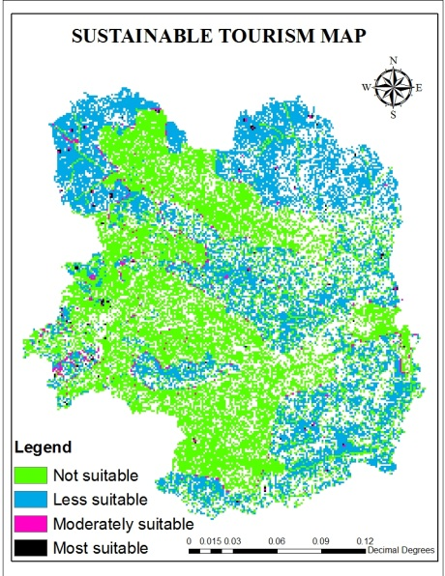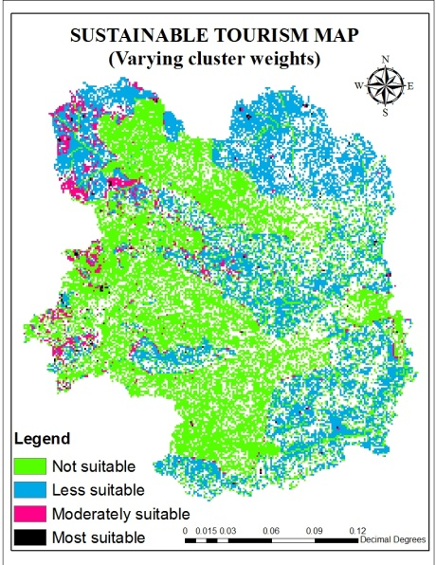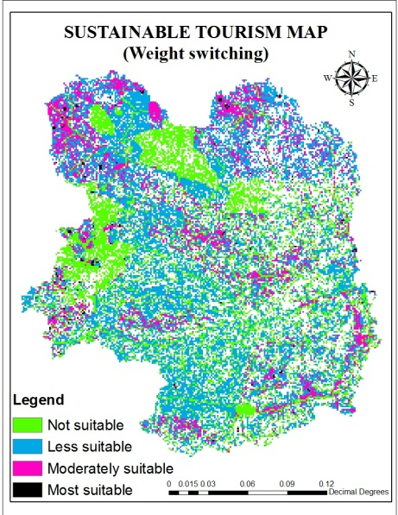
Figure 2. Sustainable tourism mapFigure 3. Sensitivity analysis 1 Figure 4. Sensitivity analysis 2

As shown in figure 2, the not suitable category occupies the significant area after less suitable category. The not suitable areas are localities that are sensitive to human disturbance such as reserved forest, habitat area, water body, steep slopes, flora and fauna. Therefore could not be used for tourism activities, except for research purpose under a strict guideline. Less suitable category are areas of the highland next to the aforementioned biodiversity that can be used by the tourist to observe the natural endowment of the highlands under the control of a tour guide. Moderately suitable areas are parts of the highland that are more distant from the biodiversity. These localities could allow for camping and be provided with lookout areas for the tourist. Lastly, the most suitable areas are parts of the highland with the least amount of biodiversity. Therefore they can accommodate low density chalets. All the above mentioned activities will be based on laid down rules and regulations to be abided by the tourist.

3.2.Sensitivity analysis
It is recommended to perform sensitivity analysis for all types of multi-criteria analysis. But, due to the complex nature of ANP models, this type of analysis is seldom performed. The direct changes in the relative weights obtained from the expert’s judgment were used to demonstrate the robustness of the model and support decision making.Two scenarios were generated by making two types of changes in the priorities obtained. The first scenario involves a simplified form of clustercomparison. The purpose of this analysisis to showthe advantages and weaknesses of the more complex calculationsof cluster weights (table 4). Complex clustercomparisons are desirable in every ANP problem [14]. In the second scenario relative weights of two factors were switched i.e water quality and slope (table 5). This case should answer the uncertainties that appeared during the factor evaluation process.
Sensitivity analysishas led to the drawing of conclusions. First,in the case of varying cluster weights (figure 3) excessive differences between the relative weightings of the factors were observed (table 4). Secondly,the importance of water quality was demonstrated by giving it the value of slope which is lower than its original value (table 5) which shows a reduction in its dominance on the map (figure 4).

4. Conclusion
The model in the study exemplifies the possibility of using ANP method with expert opinion to evaluate physical processes such as sustainable tourism. An important aspect of the approach proposed here is its hybrid nature, which combines spatial data with expert evaluations. In order to run the model, the spatial data were compiled from various sources thus represent objective data. Other aspects of the information used by the model were collected from the expert’s opinion and introduced into the model.
Another point worth highlighting is the network structure of ANP. This can be regarded as one of the strength of the method, since it offers the possibility of simulating complex physical processes through expert opinion. The major hitch of the network structure is the large number of pairwise comparisons needed for its implementation. Thus, even with a simple network structure of this case study, there were a large number of pairwise comparisons. Greater potential of ANP over analytic hierarchy process (AHP) must also be discussed, in that it allowed for interaction and feedback among factors responsible for sustainable tourism development. Indeed, the network structure is an important advance on a hierarchical structure. However, the cost of this advance is the greater number of pairwise comparisons required as mentioned earlier. The model could be replicated in highlands with similar characteristics to the one in focus; due to its flexible nature of accommodating changes in the decision maker’s preference. These could be achieved by modifying sustainable tourism development factors and interdependences based on the local condition.
References
[1]Regional Environmental Awareness Cameron Highlands (REACH) 2009 Development has gone unsustainable. Organization Review Report
[2] Malaysian Nature Society (MNS) 2000Cameron Highlands-Worth Saving or Not. Press release
[3] Aminu M 2009 A Geographic Information System for Sustainable Tourism Planning: An integrated approach, VDM Verlag Dr. Muller Aktiengesellschaft& Co. KG
[4] Berry J K.1991 GIS in island resource planning: A case study in map analysis. In D Maguire et al. (eds) Geographical Information Systems: Volume 2 Applications. Harlow: Longman
[5] Abed M H, Monavari M, Karbasi A, Farshchi P and Abedi Z 2011 Site Selection Using Analytical Hierarchy Process by Geographical Information System for Sustainable Coastal Tourism2011 International Conference on Environmental and Agriculture Engineering IPCBEE vol.15(2011) © (2011) IACSIT Press, Singapore
[6] Butler R W 1993 Tourism-an evolutionary perspective. In J.G. Nelson, R.W. Butler, and G. Wall (Eds.) Tourism and Sustainable Development Monitoring, Planning, Managing. Waterloo, Ontario: Department of Geography, University of Waterloo
[7] Minagawa Y and Tanaka N 1998 Application of Geographic Information Systems to Tourism Development Planning: A Case Study of Lombok, Indonesia. Nagoya, Japan: UNCRD Research report Series No. 27
[8] Beedasy J and Whyatt D 1999 “Diverting the tourists: A spatial decision-support system for tourism planning on a developing island”, International Journal of Applied Earth Observation and Geo-informationVolume 1, Issues 3–4, 1999, Pages 163–174
[9] Bunruamkaew k and Murayama Y 2011 Site Suitability Evaluation for Ecotourism Using GIS & AHP: A Case Study of SuratThani Province, Thailand. International Conference: Spatial Thinking and Geographic Information Sciences2011
[10] Long Island Sound Study (LISS) 2003 Long Island sound habitat restoration initiative: technical support for coastal habitat restoration. United States Environmental Protection Agency Long Island Sound Office, Stamford
[11] United States Fish and Wildlife Service (USFWS) 1996 Significant habitats and habitat complexes of the New York bight watershed. US Fish and Wildlife Service, Charlestown
[12] Saaty T L 1980 The Analytic Hierarchy Process: Planning, Priority Setting, Resource Allocation. McGraw-Hill, New York
[13] Meszaros C Rapcsak T 1996 On sensitivity analysis for a class of decision systems. Decision Support Systems 16, 231–240
[14] Nekhay O, Arriaza M and Boerboom L 2009 Evaluation of soil erosion risk using Analytic Network Process and GIS: A case study from Spanish mountain olive plantations: Journal of Environmental ManagementVolume 90, Issue 10

